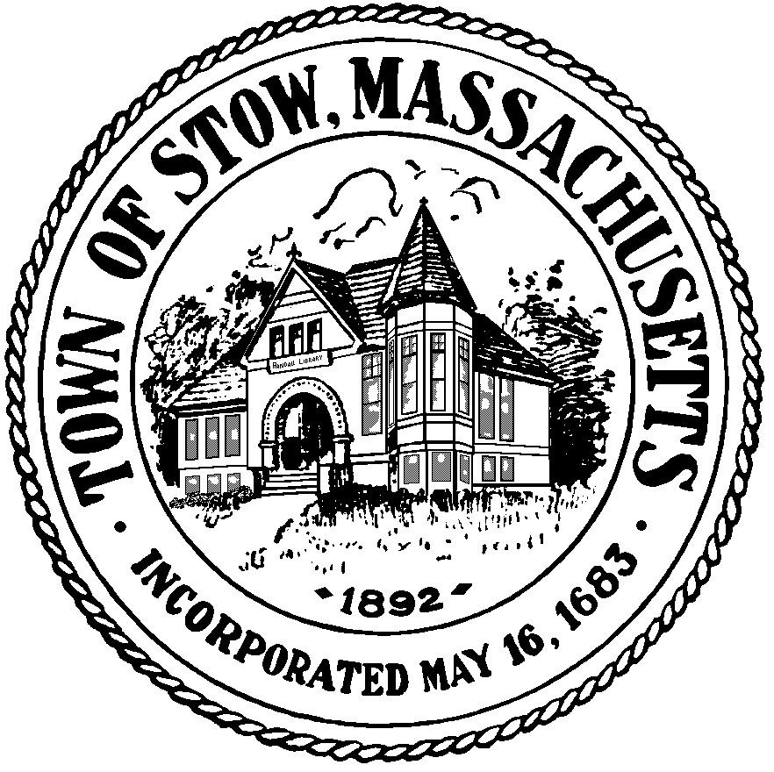

Town of Stow

community preservation committee

** Meeting will start at 8:30pm **

Agenda for Monday, March 7, 2011 7:30pm, Town Building
BILLS & MINUTES
NEWS AND VIEWS
WARRANT ARTICLES FOR ANNUAL TOWN MEETING
UPDATES ON CURRENT PROJECTS
NEW BUSINESS

Update - Meeting delay posted 3/7/11

